**Leo Victoria State Conference**

Vermont Secondary College

Morack Road, Vermont.

21st April, 2018

9.30 – 10am Registration and Morning Tea

10am Welcome – District Governor – Pat Mills

10.15am Welcome Leo Chair – Kyla Perez

10.20am Leo Pledge – Tara Schwatz

10.25am Introduce yourself to the Leo sitting either side of you and tell them what you are passionate about.

10.30am Keynote Speaker – Brian Buchanan (a professional mentor to Australian and International business leaders. Bio attached)

Developing your Leadership Skills

11am Forum 1

What makes a good leader. (Nominate a participant to give a five-minute overview of discussion to conference)

Forum 2

Setting and achieving goals. (Nominate a participant to give a five-minute overview of discussion to conference)

11.45am Presentation of Outcomes – Questions from floor

12.15pm Lunch – Karen Fuhrman has offered to cater.

1.15pm Keynote Speaker – Mary Colson (Bio attached)

Restart Africa

1.45pm Forum 3 – Global citizens, acting locally

Forum 4 - Ideas for a better Leo’s community

2.15pm Presentation of Outcomes – Questions from floor

2.45pm Leo Forum. Thinking on your feet

3pm Close – Kyla Perez



**The Sanata Charitable Trust**

**P. O. Box 150-20116 Gilgil, KENYA**

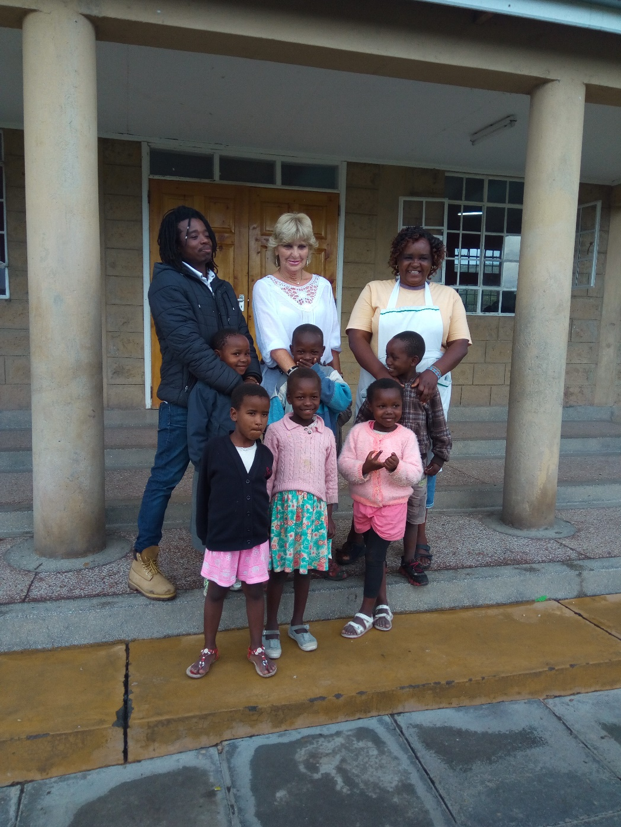

*Left to Right: Marvine, Mary and Lucy (girls matron)*

MARY COULSON - BIO

Mary is British National who came to Kenya as a teacher and has lived there for over 40 years. Her family has been involved in many projects to uplift the community around Gilgil and these include building two High Schools which were later given to the government and building classrooms for the local Primary School.

In 2008 she founded Restart Africa (The Sanata Charitable Trust), a charity that runs a home for vulnerable, abused and abandoned children in Gilgil and indeed Kenya. She is involved actively in running the charity and the four community projects it operates.

It is because of her work with the most vulnerable in the Gilgil community that led to the recognition of her work and its impact by the British Government. She was awarded honored with an MBE (Member of the British Empire) by His Royal Highness Prince Charles Philip Arthur George, Prince of Wales.

In addition to all the charitable work she does, Mary is a registered homeopath and runs an alternative medicine clinic in Nairobi where she treats all manner of ailments and conditions.

Brian Buchanan



Brian has been working with Fortune 500 companies for the past 20 years. Over this

time, Brian has worked closely with Senior Leaders and facilitated a range of leadership

and personal development programs, focusing on coaching and mentoring, leading in

change, and leading performance.

Brian is a highly regarded executive coach and is currently working with a number of

executive level leaders in science and technology organisations. Executive Coaching is a

natural fit given his background, and his approach to coaching and mentoring is based

around reflection and practical application of ideas and theories.

More broadly, Brian has partnered with many large multi-national organisations,

providing expertise in the design and facilitation of senior / talent development

programs and enhancing vertical leadership development. Brian has worked in UAE,

Asia, and is currently working with a diverse range of corporations including CSIRO,

BMW, Multiplex, the International Rice Research Institute (IRRI), Penske Group, The

World Mosquito Program, and Monash University.

Prior to consulting, Brian held senior management roles in finance and in human

resources with a major Australian bank, leading larger teams in complex environments.

This experience has proved to be the best kind of preparation for working closely with

senior leaders navigating through complexity and ambiguity.

Brian holds a Bachelor of Education, Graduate Diploma of Special Education, and a

Diploma of Education.